INTRO
Model Architecture
basically in ablation studies, people compare accuracies of models, with prsence and absence of different layers

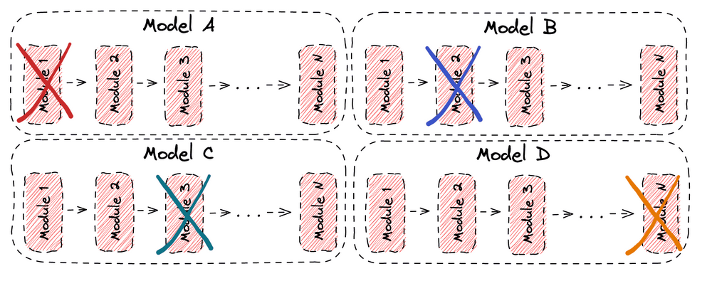
images per training clas and obj subclass

In hyper parameter tuning, we need to find optimisation algos or stuff
Learning rate is the rate at which an algorithm updates estimates
- Learning rate decay is a gradual reduction in the learning rate over time to speed up learning
- Momentum is the direction of the next step with respect to the previous step
- Neural network nodes refers to the number of nodes in each hidden layer
- Neural network layers refers to the number of hidden layers in a neural network
- Mini-batch size is training data batch size
- Epochs is the number of times the entire training dataset is shown to the network during training
- Eta is step size shrinkage to prevent overfitting

